


THE REAL SCHOOLS
LEARNER’S EMPOWERMENT ACTIVITY
P.4 SST TERM 1 2025
TOPIC PHYSICAL FEATURES OFUGANDA

Makindye Junior School

Golden Junior
School

Victoria P/S

An excellent first grade and excellent character for every pupil

NAME…………………………………………………………………CLASS: …………………
SCHOOL…………………………………………………………………………………………..

SESSION FIVE
Theme: Living together in our district
Topic: Physical features of Uganda.
Sub-topic: Lakes in our district
Learning outcome: What I will be able to know
The earner is able to explore, understand and appreciate the value of his/ her immediate and district environment for better health and harmonious living.
How to use this knowledge in my daily life
Relevance
The leaner understands the importance of lakes as source of fresh water and this can encourage learners to conserve water.
SESSION ONE
How to use this knowledge in my daily life.
Relevance
The learner knowing lake dynamics can lead to careers in water management, ensuring the sustainable use lake resources
Competences.
- Defines Alake
- Describe the types of lakes with aid of map symbols.
What I already know (Back ground knowledge)
Before learning about lakes in our district learners need to know sources of water in our district.
Learned- centered approach:
Imagine you ask where the water in the tank at home is got from. Mention any three sources of there
Key Learning principle
Alake is amassed of non- flowing water on the earth’s surface.
Alake is a large depression contains water.
Content.
A lake is amassed of non- flowing water on the earth’s surface.
Example of major lakes in Uganda.
- Lake Victoria (largest) Lake George.
- Lake Albert Lake Wamala.
- Lake Edward. Lake Wamala.
- Lake Kyoga. Lake Katwe (provides salts) Lake Bunyonyi
Types of lakes
- Permanent lakes
- Seasonal lakes
Permanent lakes are lakes which contain water thought the year e.g Lake Victoria
Kyoga, Albert etc.
Seasonal lakes are lakes which dry up in the dry season and get water in the wet seasons eg lake Bisina, Opeta, Kijanabalola



A map symbol of Permanent Lake | A map symbol of seasonal lake.

Location of major lakes and rivers on the map of Uganda
A sketch map of Uganda showing major lakes and rivers

Mini activity
1. What do you understand by the term Alake.
_____________________________________________________________
2. Mention any two lakes found in Uganda
i)_____________________________ ii)_____________________________
3. Name one type of lake you know
____________________________________________________________
4. Which Lake provide us salt in Uganda
_____________________________________________________________
5. Draw the map symbol of a seasonal lake

Mega activity
1. Give the meaning of a permanent lake
___________________________________________________________
2. What is the largest lake in Uganda.
___________________________________________________________
3. Name the map symbol below
_____________________________________________

4. What term is given to the large area of water that is surrounded by land.
____________________________________________________________
5. Which Lake is shared by Uganda, Kenya and Tanzania
____________________________________________________________
6. Give any two examples of permanent lakes
i) _______________________________ ii) _________________________
7. Why is Lake Victoria called a Permanent Lake?
___________________________________________________________
8. Mention any two sources of clean water in our district
i) _______________________________ ii) ________________________
9. What do you understand by the term seasonal lakes?
____________________________________________________________

10. Study the map below and answer questions that follow

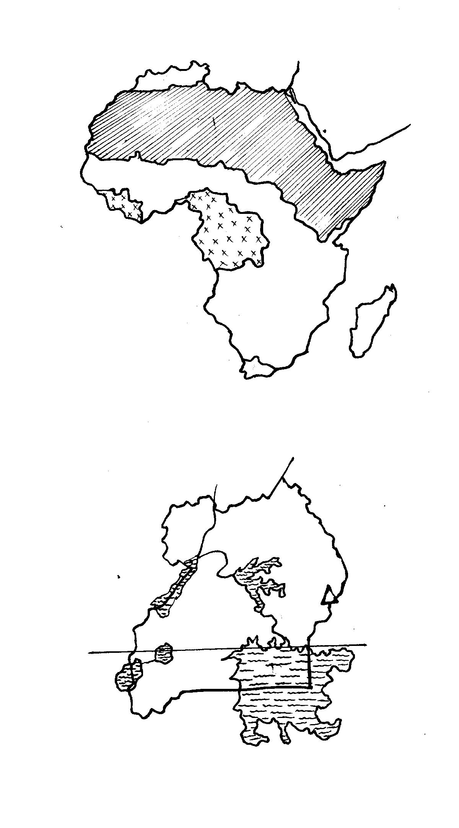
C
B
A

Name lakes marked
A: ____________________________________
B: ___________________________________
C: ___________________________________
Use letter L To locate the swampiest lake in Uganda Research
Describe the formation of convectional rain fall with aid of illustrations
SESSION TWO
Importance of lakes and Livers
How to use this knowledge in my daily life.
Relevance.
The learner appreciates the role of evaporation and condensation in rain fall formation and it can encourage learners to conserve water and water sources.
Competences.
- Identifies the economic, social and political.
- Importance of lakes and Rivers.
- Describes the formation of conversional rain fall.
What I already know.
Before learning about importance lakes in our district, learners need to know the uses of water in our environment.
Learner centered approach:
Name any two things’ activities in your home that cannot take place without water.
Key learning principles
Importance means uses/ benefits/ advantages
Content
Importance of lakes and rivers
- They help in rain formation.
- They act as fishing grounds.
- They attract tourists who bring in income.
- They are homes for some animals E.g. Fish crocodiles frogs.
- They form natural boundaries between places
- They provide water for irrigation, domestic use and industrial use for example cooling machines
- They are used for recreation activities e.g., swimming boat riding
Mini activity.
1. Mention one political use of lakes and rivers
_____________________________________________________________
2. State two ways how lakes and rivers are useful to people
_____________________________________________________________
_____________________________________________________________
3. Name one industrial use of got from lakes and rivers
_____________________________________________________________
4. Identify any two animals that live, in lakes and rivers
i) __________________________ ii) ______________________________
Formation of Convectional rain fall
- Convectional rain fall is formed as a result of evaporation, transpiration, condensation.
- High temperatures over heat water bodies cause evaporation.
- When sun rays heat the plants such as trees then it causes transpiration.
- The water vapor from water bodies and plants go to the atmosphere and condense to form clouds
- Due to heaviness, the clouds break and fall on earth as rain

NB: Convectional rain fall is mostly received around large water bodies and forested areas.
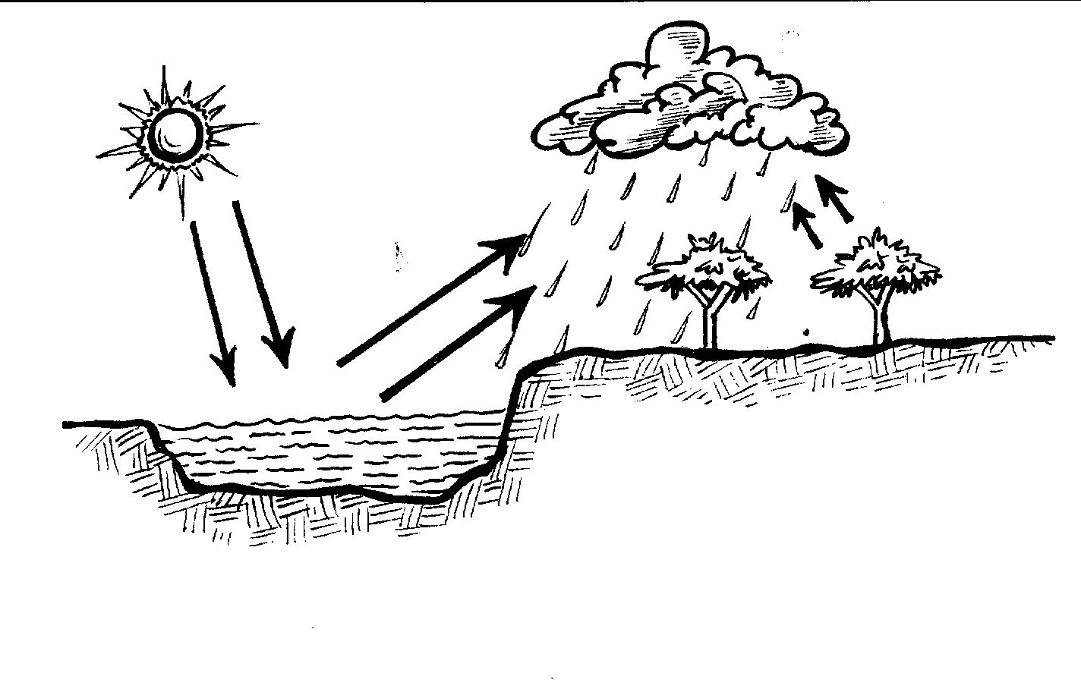

Water bodies
condensation
transpiration
evaporation
Sun rays

Processes involved in the formation of convectional rain fall
Transpiration
Is the process by which plants loose access water in form of water vapor to the atmosphere.
Condensation is process by which vapour changes to liquids (water)
Mega Attentivity
1. Mention the three processes involved in the formation of conventional rain fall
____________________________________________________________
____________________________________________________________
______________________________________________________________
2. Which type of rain fall is always received near lakes.
____________________________________________________________
3. Which process takes place in plants.
____________________________________________________________
4. Name one domestic use of water got from lakes and rivers
____________________________________________________________
5. Which term is given to the process where plants loose water in form of water vapor to the atmosphere
__________________________________________________________

6. How are lakes and rivers useful to frogs
___________________________________________________________
7. How is the water body useful during the formation of convectional rain fall
_____________________________________________________________
8. How are lakes and rivers help plants to grow well.
_____________________________________________________________
9. Which process takes place in the clouds.
____________________________________________________________
10. Study the diagram below and answer questions that follow
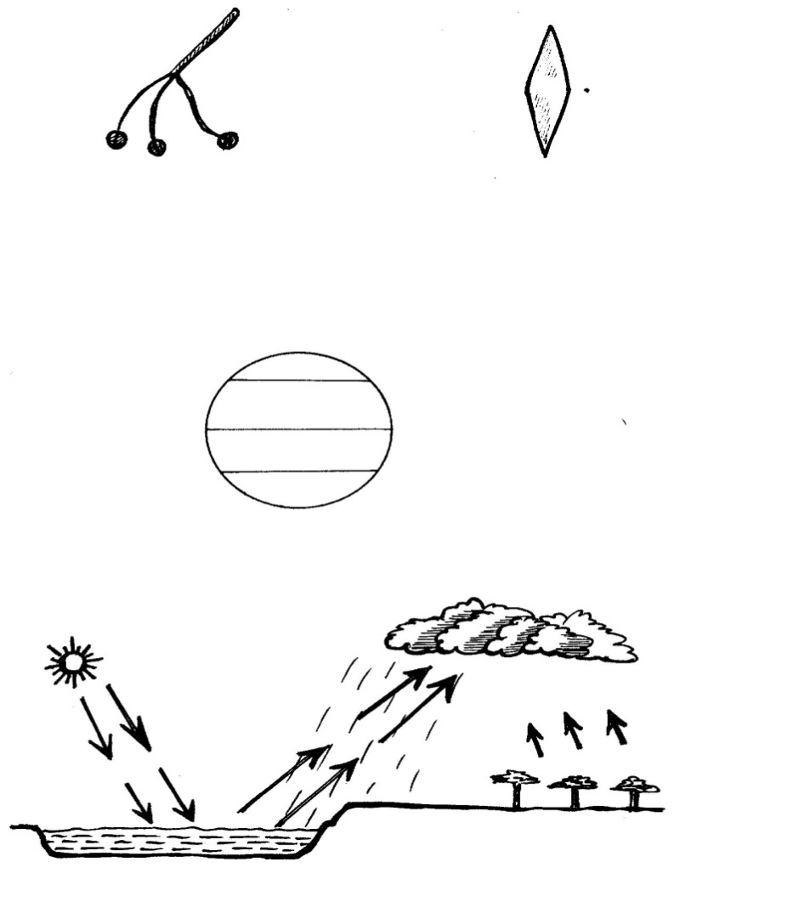
B
C
A

Name process marked;
A_____________________ B ______________________ C___________________
Reach
Mention any three activities carried out around lakes and rivers.
________________________________________________________________________________________________________________________________
________________________________________________________________
SESSION THREE
How lakes influence people
How to use this knowledge in the daily life.
Relevance
The learner can educate the community about lake safety such as warning signs, emergency procedures and water safety tips.
Competences.
- Identifies economic activities carried out near lakes.
- Identifies resources obtained from lakes.
- Identifies ways of caring for lakes.
- Identifies reasons why lakes shores are densely populated.
What I already know (Back ground)
Before learning about the dangers caused by lakes and rivers, learners need to know the dangerous animals found in lakes and rivers.
Learner centered approach
Imagine you stay near water body
Mention any three good things and bad thing you can face.
Economic activities Things done near lakes to get money.
Dangers bad disadvantages of settling near lakes and rivers.
Caring Proper ways of using lakes and rivers.
Content.
Economic activities carried out on and near lakes
- Fishing Mining
- Crop growing Tourism
- Transportation
Resources/ important things obtained from lakes.
- Sand salt
- Fish soda ash for making glass papers detergents.
- Water
Dangers caused by lakes and rivers
- Drawing.
- Flooding
- They harbour dangerous aquatic animals like snakes, crocodiles.
- They harbour diseases vectors like black fly hinder road and railway construction
Mini Activity.
1. Mention any three economic activities carried out on and near lakes.
_____________________________________________________________
_____________________________________________________________
_____________________________________________________________
2. Name any two things obtained from lakes
i) ____________________________ ii) ____________________________
3. State any two dangers caused by lakes and rivers
____________________________________________________________
_____________________________________________________________
4. Outline any two products made from soda ash.
i) _____________________________ ii) __________________________
5. Which product got from lakes is used for building.
_____________________________________________________________
Problems facing lakes and rivers
Silting
This reduces the depth of water bodies
- Overuse of water from lakes for irrigation.
- Drought which lowers the water level.
- Dumping of wastes into water bodies.
- Over fishing.
Caring for lakes.
- By using proper fishing methods.
- By planting trees around lakes.
- By treating industrial wastes before dumping them in lakes.
By teaching people about the importance of lakes.
Reasons why lakes shores and river banks are densely populated.
- They have fertile soils for crop growing.
- They receive reliable rain fall.
- They have a lot of job opportunities.
Mega activity
1. Give one why lake shore is densely populated.
____________________________________________________________
2. Name one dangerous aquatic animal found in lakes and rivers.
_____________________________________________________________
3. Mention any two ways of caring for lakes

__________________________________________________________
____________________________________________________________
4. Identify two dangers faced by people living near lakes and rivers
____________________________________________________________
____________________________________________________________
5. How does silting spoil the t lakes.
_____________________________________________________________
6. What causes flooding of lakes.
____________________________________________________________
7. State one problem facing lakes and rivers
____________________________________________________________
8. Name one product got from lakes that is used to preserve food.
____________________________________________________________
9. Mention one place with fertile soils and reliable rain fall.
____________________________________________________________
10. Give one disease vector found near lakes and rivers.
____________________________________________________________
Research
Give the meaning of a river.
SESSION FOUR
Rivers in Uganda.
How to use this knowledge in the daily life
Learner understands the importance of rivers as a source can encourage learners to conserve water.
Competences.
Defines river
- Identifies different source of water to rivers.
- Identifies examples of major rivers in Uganda.
- Describes different types of rivers.
- Identifies the stages of river development.
What I already know (Back ground knowledge)
Before learning about rivers, learners need to know sources of water in our district.
Key learning principle
A river is amassed of flowing water on the earth’s surface.
Stages can also mean phases, steps
Content.
- A river is amassed of flowing water on the earth’s surface.
- Rivers flow from areas of high altitude to areas of low altitude.
- Rivers autiously get their water from rain fall, melting snow from high mountains or underground springs
- Some rivers originate from highlands because such areas receive plenty of water which is a source of water to rivers
Examples of major rivers to in Uganda.
- River Nile longest River Achwa.
- River Kafu River Katonga.
- River Mayanja River Sezibwa.
- River Kagera River Manafwa
Mini activity
1. What do you understand by the term a river?
____________________________________________________________
2. Outline four examples of rivers.
i) _______________________________ ii) _________________________
iii) _______________________________ iv) ________________________
3. What is the longest river in Uganda?
______________________________________________________________
4. How do rivers flow.
_____________________________________________________________
5. Give one place where rivers originate
_____________________________________________________________
Types of rivers
Permanent rivers:
These are rivers which flow thought river the year.
Examples of permanent rivers in Uganda
- River Nile River Achwa.
- River Kafu River Katonga.
- River Kagera River Sezibwa.
Seasonal rivers: these are rivers that mainly flow during the wet season and dry up during the dry season
Map symbols related to rivers
Seasonal river
dam
Water falls
Permanent river

Stages of river development.
A river has three main stages/ courses
These are.
- The youth stage/ Middle course.
- The Old stage/ lower stage (senile)
Mega Activity
1. How many stages does a river take to develop?
_____________________________________________________________
2. Mention the two types of rivers
i) _______________________________ ii) _________________________
3. What name is given to the first stage of river development.
____________________________________________________________
4. Name the map symbol below.

________________________________

5. Mention any two examples of permanent rivers.
i) ___________________________ ii) _____________________________
6. Give the meaning of seasonal rivers
_____________________________________________________________
7. Name any two sources where rivers get their water.
i) ________________________ii)__________________________________
8. Why is River Kagera referred to as a permanent river.
_____________________________________________________________
9. Give other name to mean the middle course of a river development
_____________________________________________________________
10. What term means the rivers which flow thought the year?
__________________________________________________________
11. Name the third stage of a river development
__________________________________________________________
12. Draw these map symbols
Dam | Seasonal river

Research
Give four importance of rivers.
SESSION SIX
Stages of river development
How to use this knowledge in my daily life.
The learner can share know ledge about rivers with others that can inspire the community members to take action in protecting rivers.
Competences
- Describe the stages of river development.
- Defines terms related to rivers.
- Identifies importance of rivers.
- Identifies problems caused by rivers.
- Identifies major economic activities carried out around rivers.
- Gives general importance of physical features.
- Identifies dangers and ways of caring for the physical features.
What I already know (Back ground knowledge)
Before learning about importance of rivers, learners need to know the examples of rivers in Uganda

Key Learning principle
Importance means / uses/ benefits/ advantages.
Dangers means problems/ disadvantages.
Economic activities
It means activities done around rivers to make money.
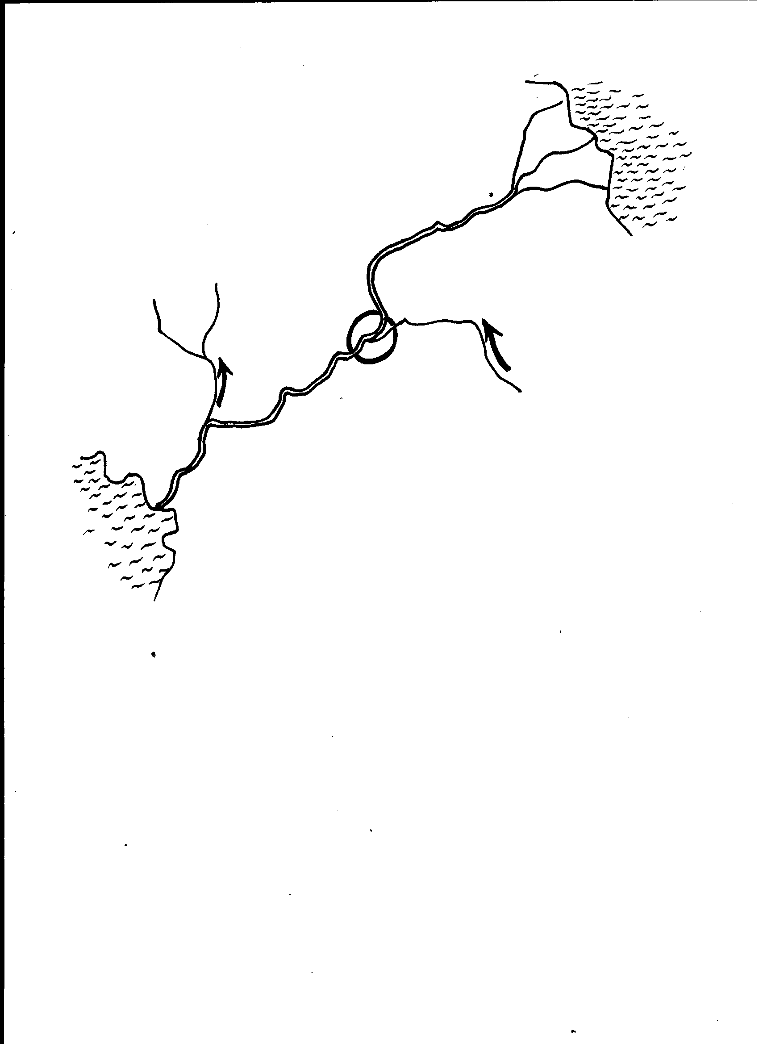
Content
River source
confluence
delta

distributary
tributary
.
meonder

Lower stage
Upper stage
Middle
stage
A diagram showing a river system

Terms related to rivers.
- A river source is a point where a river begins to flow.
- A river muth is a point where a river ends its flow.
- A tributary is a small river that joins the main river.
- A distributary is a small river that branches a way from the main river.
- A river confluence is a place where two or more rivers meet.
- An estuary is a wide part of a river as it ends its flow.
- A delta is the place where a river forms several streams as it ends its flow eg The Nile delta
Mini Activity
1. What do you understand by a river source
_________________________________________________________________
2. What term is given to small river that joins the main river
________________________________________________________________
3. Give the meaning of river mouth.
________________________________________________________________
4. Write down the three stages of river development
________________________________________________________________
________________________________________________________________
________________________________________________________________
5. Give the meaning of an estuary
_______________________________________________________________
Note
Delta has rich fertile soil for crop growing.
- They also attract tourist who bring in come.
- A water fall is a stee flow of arriver.
OR. It Is appointed where a river flows from high altitude to a low altitude.
- A cataract is a series of waterfalls on a river.
- Waterfalls attracts tourist who bring in income help in germination of hydroelectricity, and are also used for recreation.
- However, waterfalls may cause water accidents and also block water transport
Example s of waterfalls in Uganda.
Karumafalls, Sipifalls , Murchison fall
Importance of rivers.
- They are a source of fish
- They help in the formation of rain.
- They are source of income through tourism.
- They provide water for domestic use like bathing.
- Rivers help in the generation of Hydroelectric power/ hydroelectricity
(HEP)
- They act as recreation centers.
Mini Activity
1. Mention any two importance of rivers.
________________________________________________________________
_______________________________________________________________
2. Write H E P in full.
______________________________________________________________
3. How are waterfalls importance to Uganda.
______________________________________________________________
4. Give one domestic use of water got from rivers
_______________________________________________________________
5. Mention one use of delta as to people
_______________________________________________________________
Problems caused by rivers in an area.
- Drowning
- Flooding.
- Rivers are breeding places for diseases vectors E.g., mosquitoes.
- They hinder road construction.
- They harbour dangerous animals like snakes.

Economic activities carried out on and around rivers
- Fishing.
- Transportation. Tourism
- Mining Crop growing
General importance of physical features
- Lakes and rivers are source of fish
- They help in the formation of rain
- They are source of income in tourism.
- Lakes and rivers provide water for domestic use like bathing, mopping.
- Rivers helps in generation of Hydro Electric power ( H E P)
- They act as recreation centers
- Some mountains are source of rivers.
- Mountains slopes and lake shores have fertile soils which support crop growing.
- Hills and mountains are used telecommunication companies to place on masts.
- Lakes and rivers provide water for irrigation.
- They form natural boundaries between places.
- Mountains provide building materials e.g. stones
Mini activity
1. Mention any two economic activities carried out around rivers.
_____________________________________________________________
_____________________________________________________________
2. Give three problems caused by river in an area.
_______________________________________________________________
_______________________________________________________________
________________________________________________________________
3. Identify three importance of physical features.
______________________________________________________________
_______________________________________________________________
________________________________________________________________
4. How are hills important to telecommunication companies.
______________________________________________________________
5. Name one building materials got from mountain.
________________________________________________________________
Dangers of physical features
- Some of them are hiding for wrong doers.
- They harbor dangerous wild animals.
- They are bleeding places for diseases vectors.
- Lakes and rivers flood which kill people.
- They hinder road construction.
- Mountains erupt and destroy property.
- They hinder road construction.
- Mountains are greatly affected by landslides and soil erosion
Ways of caring for the physical features
- By planting trees on shores of lakes, river banks and mountain slopes.
- By discouraging people from dumping rubbish in water bodies.
- By terracing land to control soil erosion in highlands.
- By using proper fishing methods.
- By Filling holes after mining.
- By sensing people about the importance of different physical features
- By treating wastes before disposing them in water bodies.
Mega activity
1. Mention any two ways of caring for the physical features.
____________________________________________________________
_____________________________________________________________
2. State two dangers of physical features
____________________________________________________________
____________________________________________________________
3. Name any two examples of waterfalls in Uganda.
i) _____________________________ii)____________________________
4. Give the meaning of cataract.
_____________________________________________________________
5. Which physical features is used to generate HEP.
____________________________________________________________
6. How are physical features politically important in the environment.
____________________________________________________________
7. Give one way mountain hinder economic development in an area
____________________________________________________________
8. Mention any two-tourist attraction in Uganda
i) _____________________________ii)___________________________
9. Mention any two problems faced by people living near mountains.
____________________________________________________________
____________________________________________________________
10. How do lakes and rivers help to change climate of an area.
____________________________________________________________
11. State one problems faced by people living near lakes and rivers.
____________________________________________________________

